**Text for PhD - Rees River Hydrometry – Invincible Gauging Station**

A discharge gauging station was installed approximately 1 km downstream of the confluence between Invincible Creek and the Rees River. At this location the Rees is confined to a single, un-vegetated, boulder bed channel in a gorge. In the proximity of the gauging station the channel is sufficiently confined that flow remains in-bank during storm events, the cross-section is relatively constant in a longitudinal direction, and there are no downstream tributaries or control structures that influence channel flow. The Invincible gauging site thus offers a relatively morphological stable channel, where flow is sufficiently uniform across a range of flows to measure discharge.

Water level was measured at the Invincible gauging station using a gas purge (bubbler) gauge. This type of gauge was particularly advantageous over alternative gauges because the sensors and recording devices could be located above the maximum expected flood level, thus protecting them from debris-related damage during high flows. Water level data were sampled three-times every 15 minutes, from September 2009 until March 2011. Data were logged at the station and also broadcast via a satellite telemetry system so that near real time data could be viewed online using NIWA’s Neon remote data monitoring software. A cableway was also built at the site to facilitate velocity and depth measurements across the channel.

The calibration of the gauging station, to establish a stage-discharge relationship, was undertaken throughout the period when water level was recorded. Discharge measurements and the construction of a ratings curve followed standard procedures, as outlines in Shaw (2011) and WMO (2010). Flow was gauged using a range of sensors including a Sontek RiverSurveyor S5 aDcp, a RDI StreamPro aDcp, an OTT current meter and a Gurley current meter. The choice of sensor was dependent upon flow conditions and the equipment available to the hydrometry team that were visiting the gauge. In total, 16 discharge measurements were used to construct the stage-discharge relationship. Of these, 13 discharges were measured using an aDcp. The aDcp data were extremely precise, for example the four cross-section transects that were undertaken for each discharge measurement using the RiverSurveyor were characterised by a mean covariance of 0.02 (standard deviation = 0.01, n = 6). However, the aDcp’s were difficult to deploy in high flow conditions due to a limited freeboard between the cableway and the water surface. Moreover, unfortunately the cableway was washed away during a high-flow event in April 2010. This restricted subsequent gaugings to low flow conditions when the river could be waded with ease.

Figure 1 shows a rating curve for the stage-discharge relationship at Invincible. The range of gauged discharges is biased towards low flows although the one high-flow discharge measurement, which was gauged on 9 December 2009, does allow the extension of the curve to high stages. The discharge measurements on Figure x are classified based upon whether they were taken before or after the high-flow event on 9 December 2009 because inspection of the discharge measurements, and anecdotal field observations, suggested that the bed scoured during this event. The distribution of stage-discharge measurements on Figure x confirms that the bed did scour during the event on 9 December 2009 and thus two ratings equations were fitted to the data. Although a power function is widely fitted to a ratings curve in river hydraulics (Shaw et al, 2011) for the ratings curve at Invincible this was found to give a poor fit (Figure 2 – not to be included in final). Instead, a second-order polynomial function was fitted to the data using least-squares regression (other examples of second-order polynomial function = Yu, 2000 and Baldassarre and Montanari, 2009). A single equation was fitted to each set of data because there were insufficient gaugings at intermediate to high flows to segment the ratings equation (Figure 3 – not to be included in final) and there were not enough data to determine whether a looped ratings curve would be appropriate. The least-squares fits are excellent for both sets of data and were used to construct a discharge time-series for the duration of the flow record (Figure 4).

**FIGURE 1**

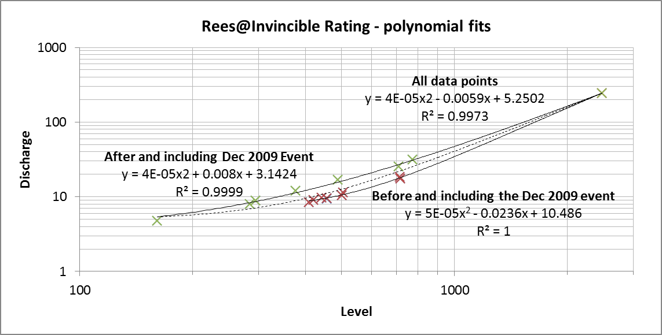

**FIGURE 2**

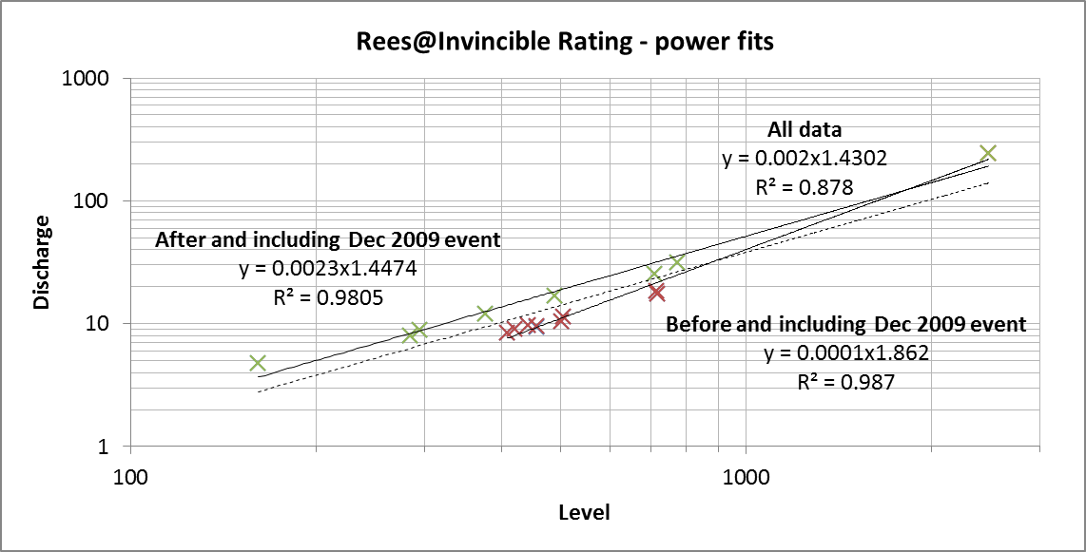

**FIGURE 3**

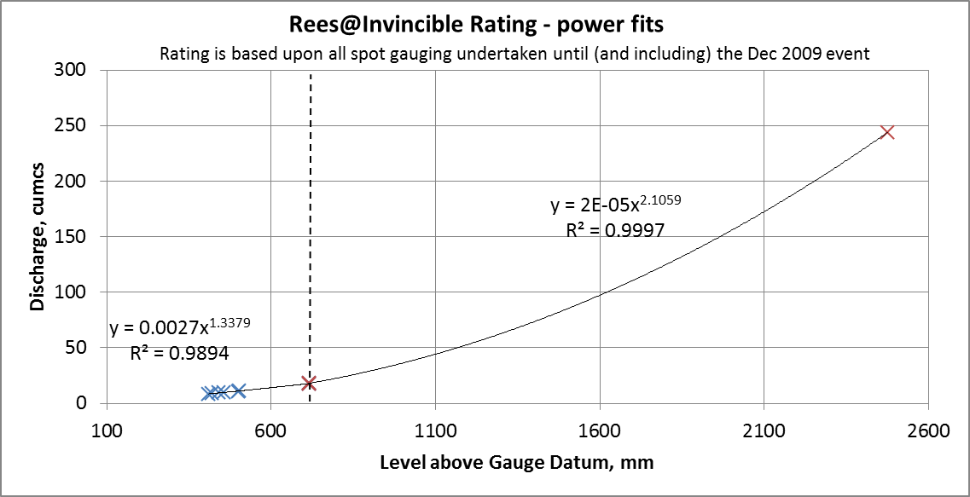

**FIGURE 4 – BASED ON POLYNOMIAL FITS**

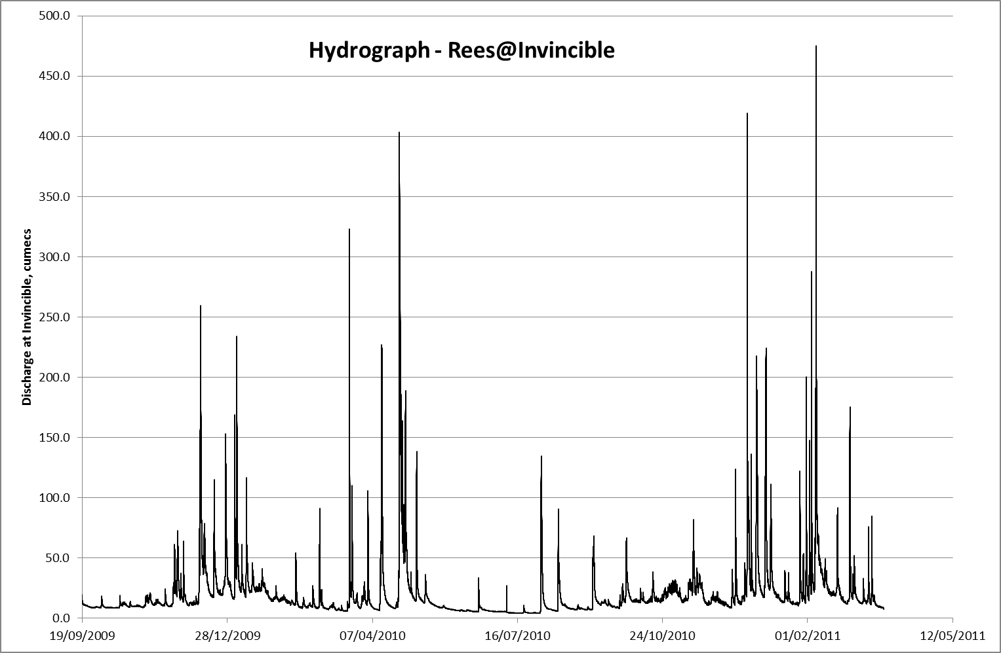

***References***

Shaw, Beven, Chappell and Lamb. 2011. Hydrology in Practice.

World Meteorological Organisation. 2010. Manual on Stream Gauging.

Yu, B.: A systematic over-estimation of flows, J. Hydrol., 233, 258–262, 2000.

G. Di Baldassarre and A. Montanari. 2009. Uncertainty in river discharge observations: a quantitative analysis, Hydrol. Earth Syst. Sci., 13, 913–921, 2009

**December 2011 – Pre-Christmas meeting between James and Richard, QMUL**

Decided to go ahead with polynomial fits for rating relationship.